Intervlan communication

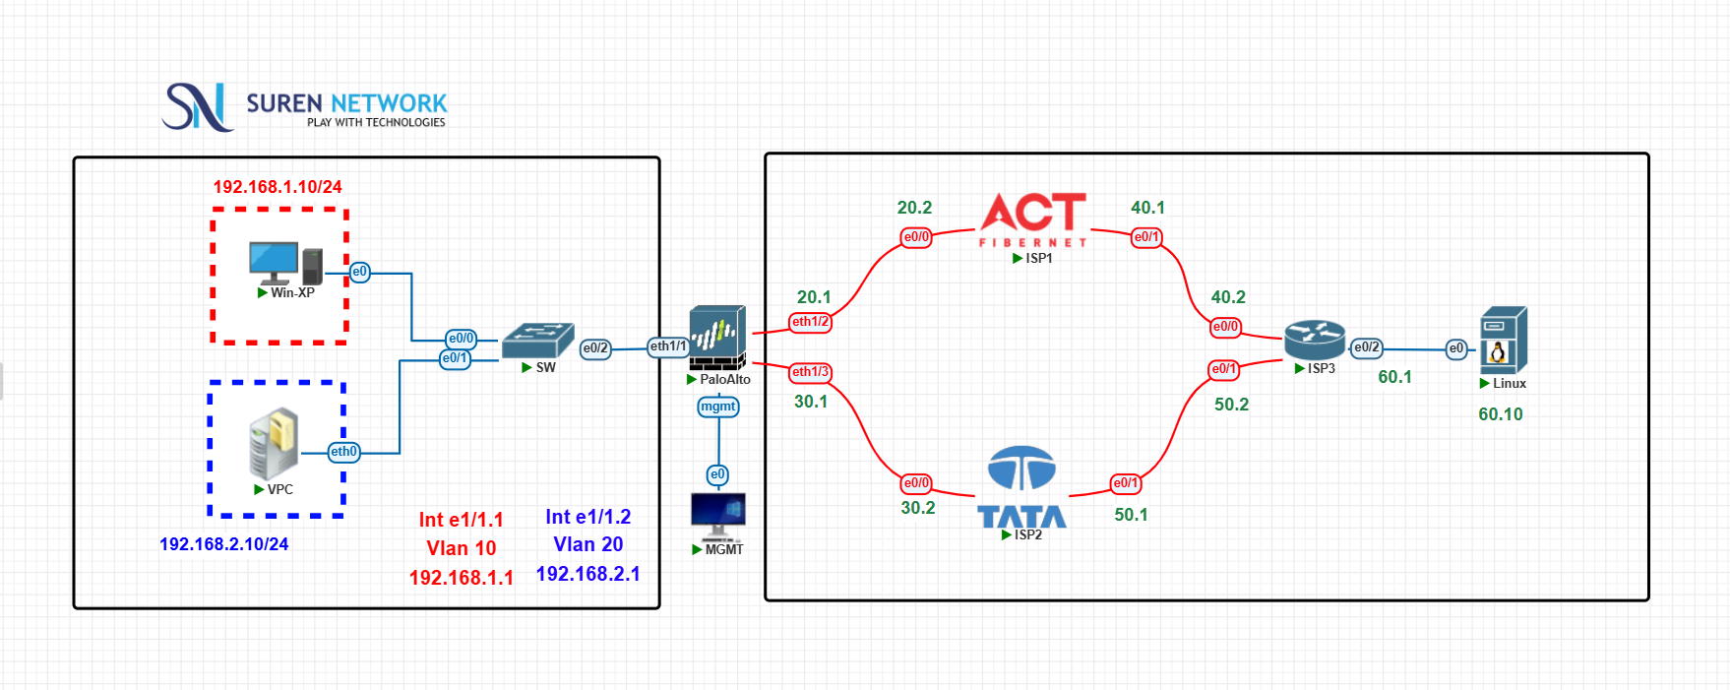
Steps:
- Login to MGMT

MGMT IP: 1.0.0.10 SUBNETMASK: 255.0.0.0
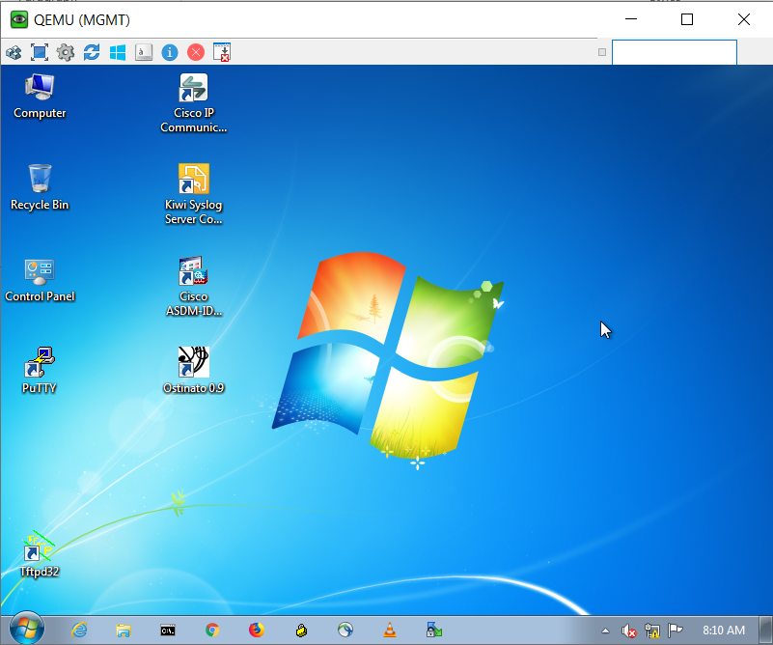

- Next Login to Palo alto

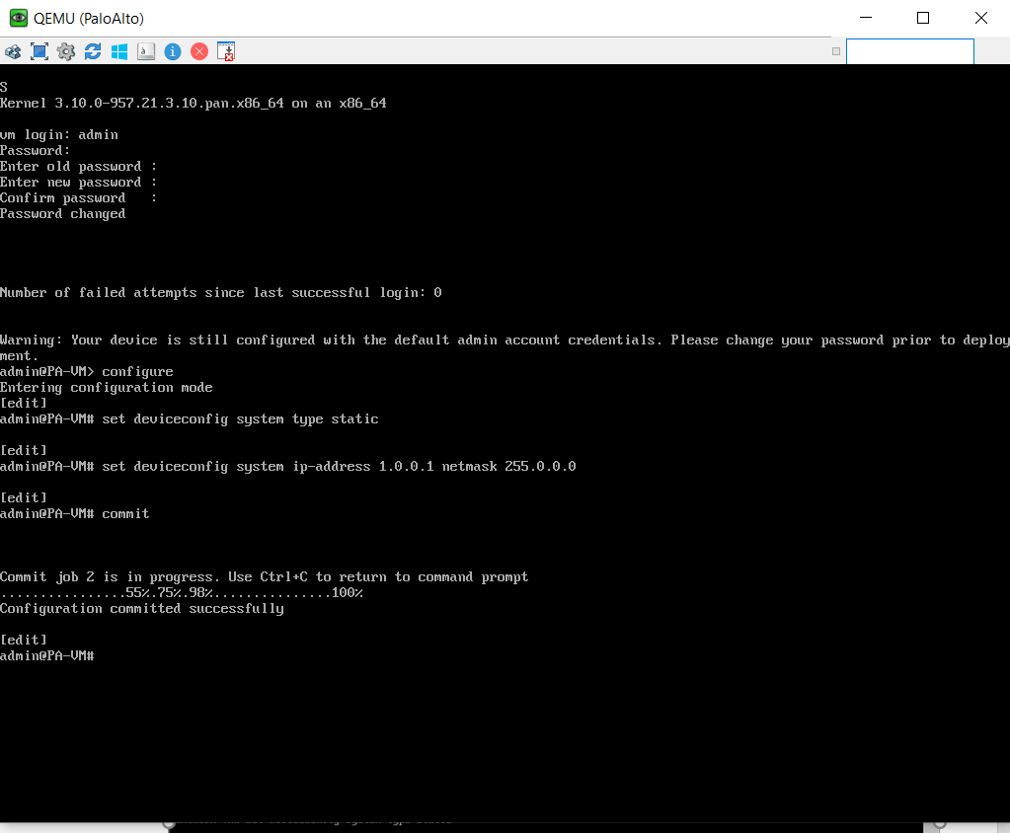

- Assign ip address for management pc and go to GUI of paloalto

PALO IP: 1.0.0.1 SUBNETMASK: 255.0.0.0

Now go to run on windows enter ncpa.cpl

Assign IP address, netmask and default gateway

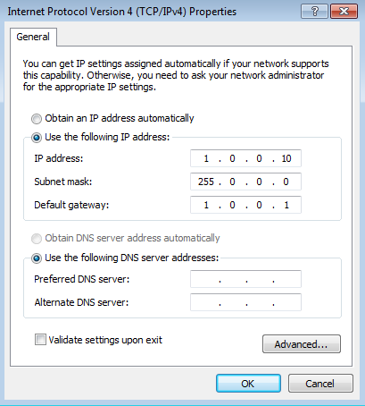

- Now enter IP address – https://1.0.0.1 to login Palo alto

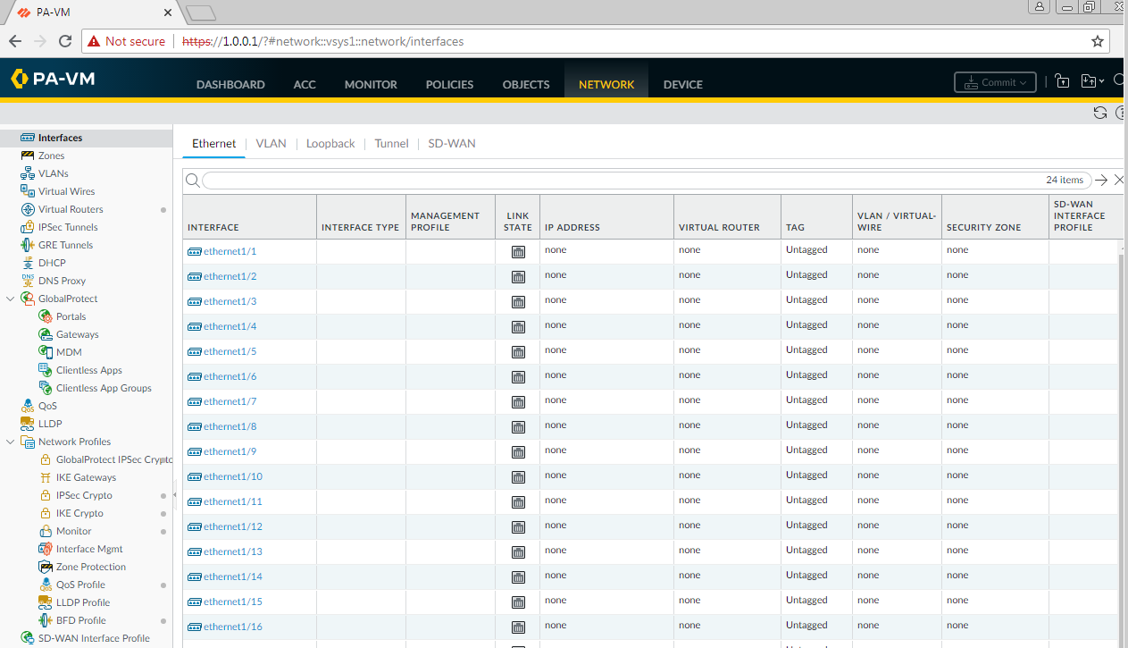

- Now go to switch give configuration to VLAN 10 and VLAN 20

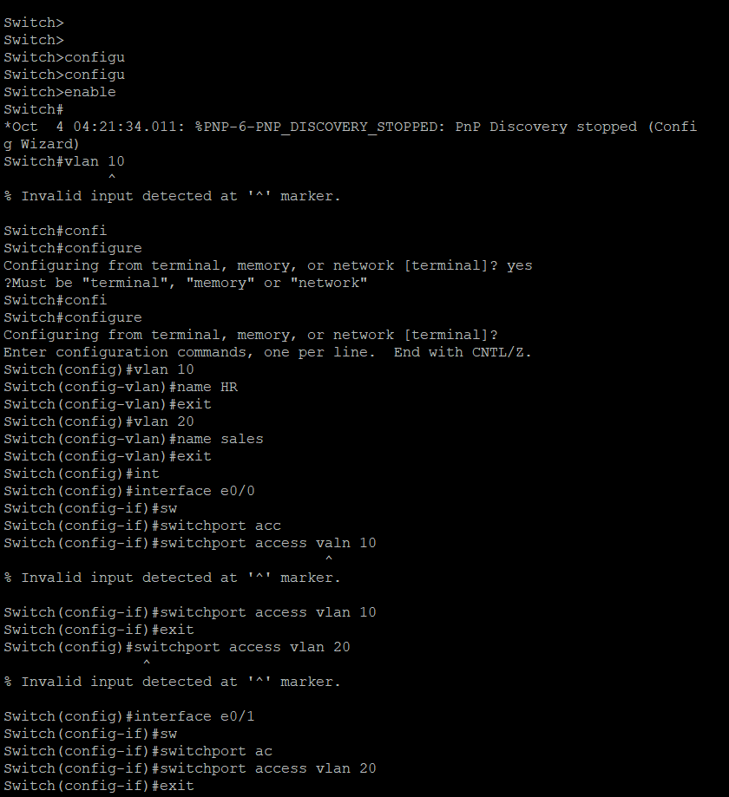
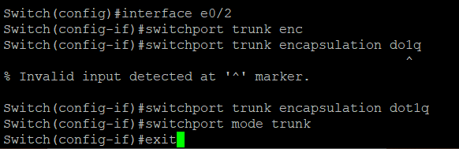

- Now create Zones in VLAN 10 and VLAN 20

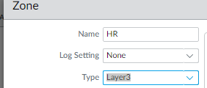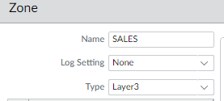

- Create INTER-VLAN communication

Go to Interfaces eth0/1 to give layer3 add sub interfaces
Add Ethernet 1/1 and give subint -1 and 2

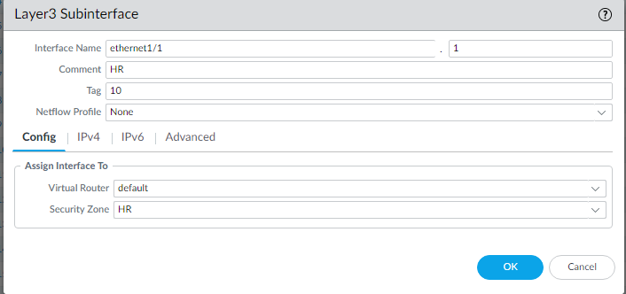
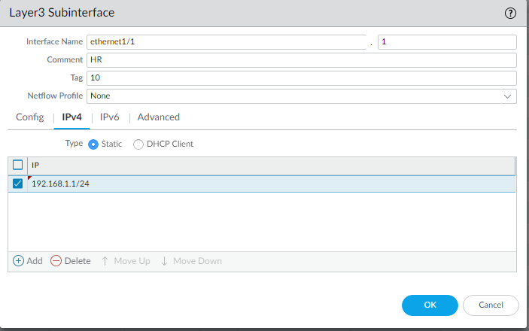

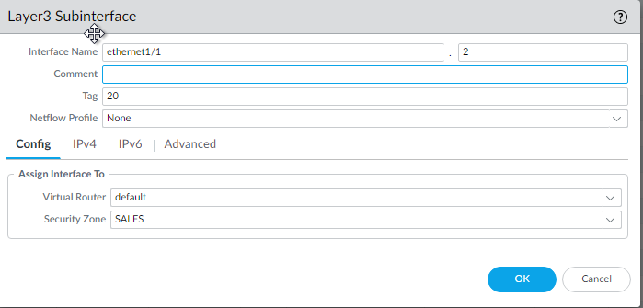
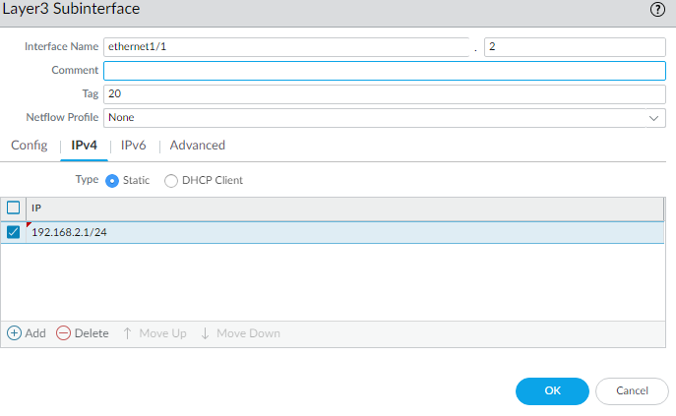
- Create bi-directional security policy for HR & Sales using object
Go to policy- Security

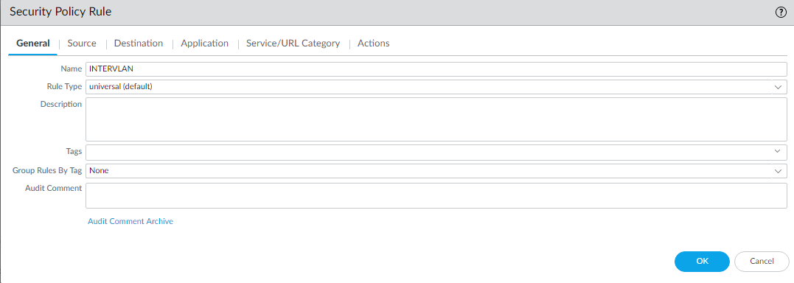
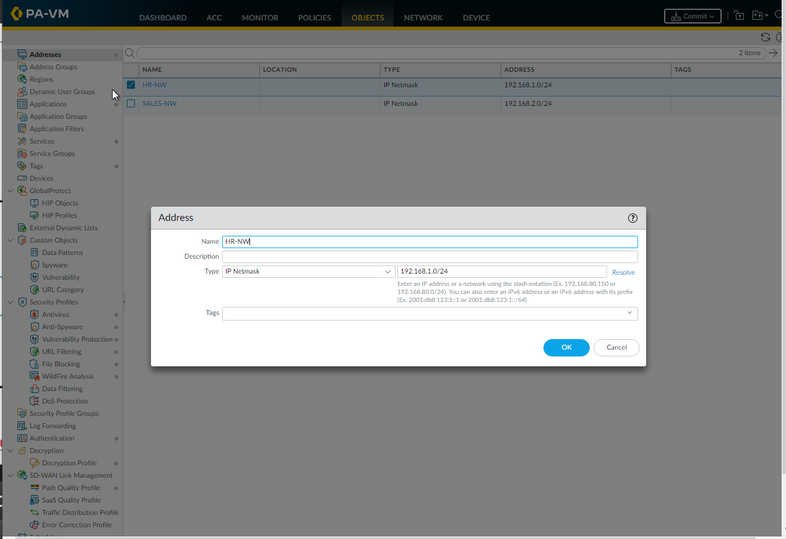

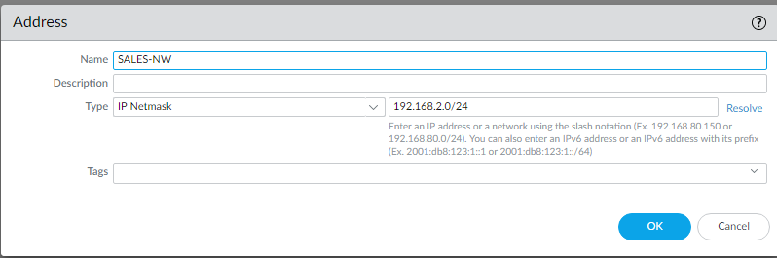

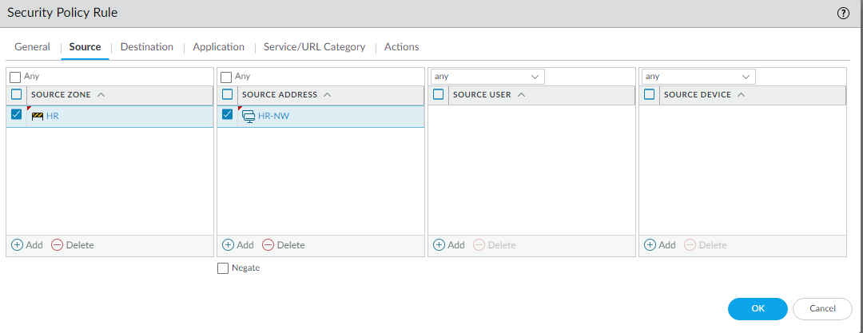
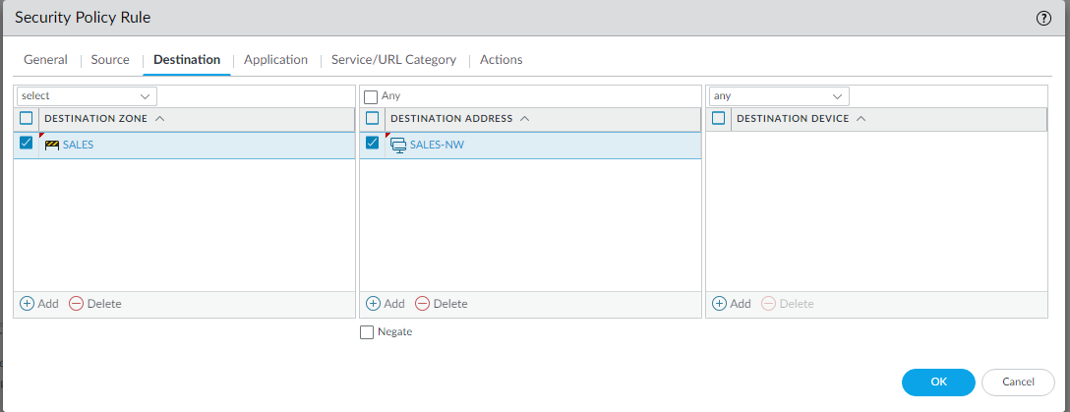

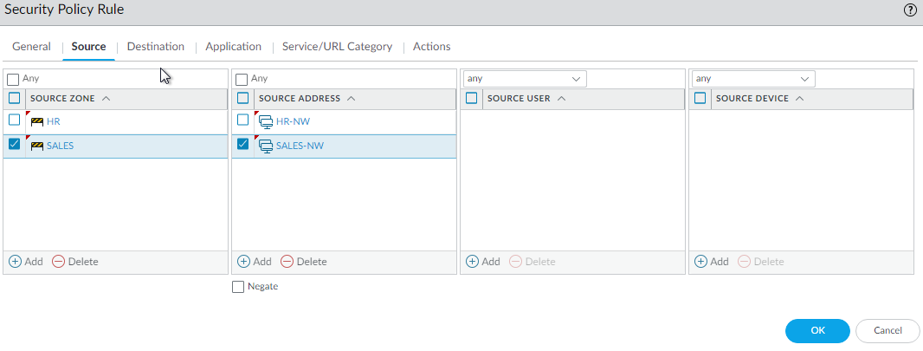
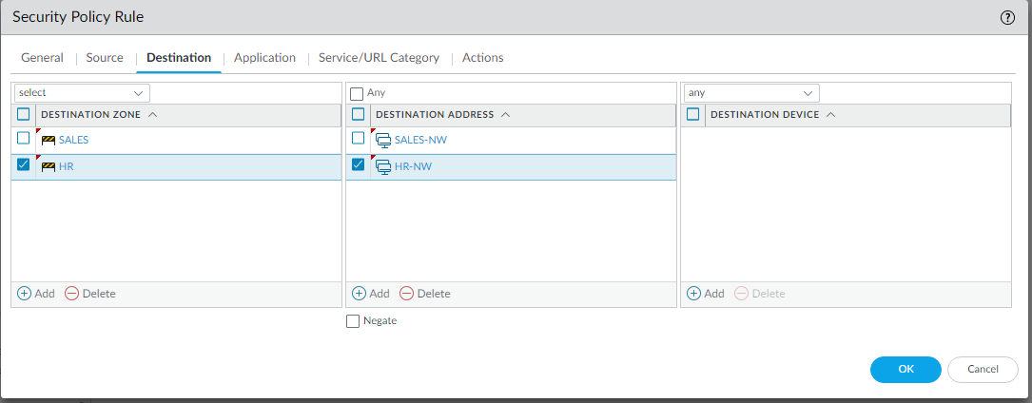

- Save the configuration

Commit

